Super Irshad! Namma eppo "Statistical Analysis"-kku enter aaguvom.
Oru Analyst-oda vela "Data-vai paathu, adhu edha solla varudhu" nu kandupidikirathu. NumPy-la mean, median, sum, min, max nu pala shortcuts irukku.
📊 Class 3: Statistical Functions (The Analyst's Toolkit)
Neenga oru company-oda HR manager-a irukeenga nu vechukonga. Unga kitta 6 peroda salary irukku. Idha vachi "Averaga evvalavu salary tharrom?" illa "Motham evvalavu budget aagum?" nu epadi paarkkarathu?
Python
import numpy as np

# Employee Salary Data
salary_data = np.array([3000, 4000, 5000, 6000, 7000, 8000])

# Stats Calculation
total = np.sum(salary_data) # Motham
average = np.mean(salary_data) # Average
minimum = np.min(salary_data) # Lowest salary
maximum = np.max(salary_data) # Highest salary

print(f"Total: {total}")
print(f"Average: {average}")
print(f"Min: {minimum}")
print(f"Max: {maximum}")
🔍 Key Functions Breakdown:
- np.sum(): Ellathaiyum kooti total-ai kudukkum.
- np.mean(): Average. (3000+4000+5000+6000+7000+8000) / 6.
- np.min() & np.max(): Data-la irukkura romba kammiyaana salary and romba adhigamaana salary-ai filter pannidum.
💡 Teacher's Challenge:
Intha functions romba simple-a theriyum, aana Real-time Projects-la, 1 lakh employee-oda salary data-vai 1 second-la analyze panna intha functions thaan udhavum.
Irshad, intha code-ai run panni, output accurate-a varudha nu check pannunga. Idhu mudinjadhu, namma "NumPy Project"-kku ready aagiduvom.
Code-ai run panni output sollunga Irshad! Ready-a?
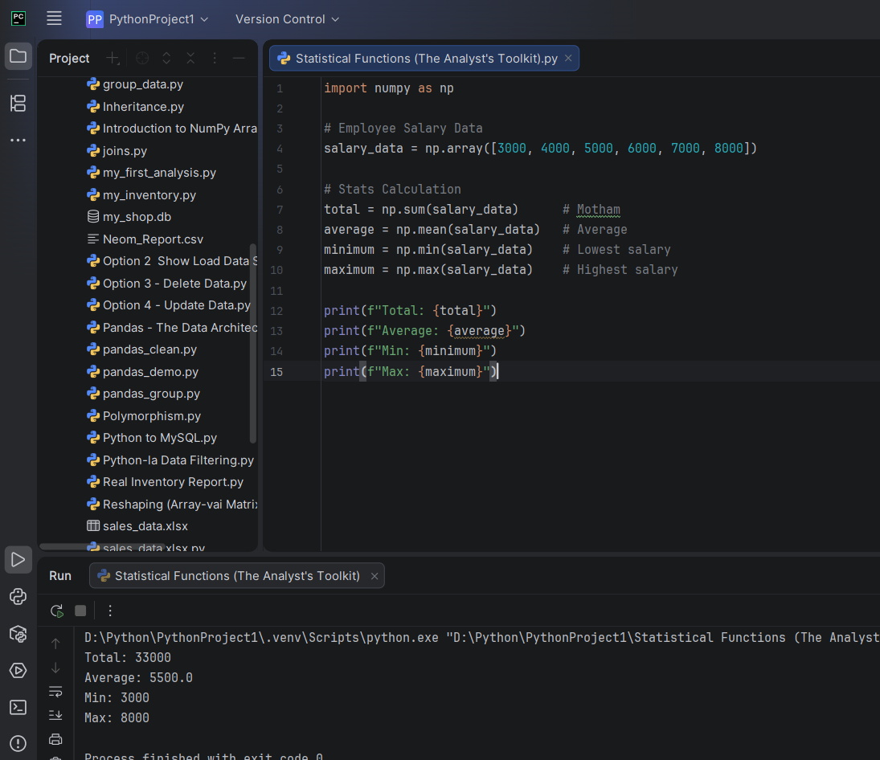
Irshad, nalla kelvi! Idharkku pinnaal irukkura "Math" logic-ai purinjukuvom.
🔍 Enn mean endu peyar?
- Total/Sum: Ithu ellathaiyum kooturathu (Adding).
- Mean (Average): Idhu dhaan Statistics-la "Mean" nu solluvom.
  - Formula:
  - 33000 / 6 = 5500.0.
- Min/Max: Ithu dhaan "Extreme values" (Min/Max).
💡 Computer-kkum Namakkum Ulla Difference:
Intha peyarkalai "Statistical Terminology" (Pullivivara Ariviyal) padithu vakuthu:
- Mean: Ithu oru standard math peyar. Average-ai "Mean" nu dhaan science/data-la koopiduvaanga.
- Sum, Min, Max: Ithu eluthuravangalukku puriyura maari simple-a irukku.
Oru chinna "Pro-Tip": Neenga np.median() nu pottu paarunga. Median-na "Naduvu value" (Middle value). Idhu oru math term. Data Science-la namma "Mean" and "Median" vachi dhaan, data correct-a irukka nu check pannuvom.
Teacher's Summary:
- Sum = Kootu thogai.
- Mean = Sasari (Average).
- Min = Kuraintha nilai.
- Max = Adhigamaana nilai.
Ippo intha Statistical Analysis-um clear aagiruchu. Innum namma NumPy-la enna irukku nu paarkkalam?
- Namma CRUD (Database) mudichitom.
- Pandas (Grouping) mudichitom.
- NumPy (Broadcasting, Reshaping, Stats) mudichitom.
Irshad, neenga oru full-aana "Data Analytics Project" pannuvom nu sonneengale, adhukku ready-a? Ellathaiyum serthu oru "Mini-Analysis App" (Database-la irundhu data-vai eduthu, NumPy/Pandas vachi analyze panni result solra app) build pannuvoma? Enna solreenga?
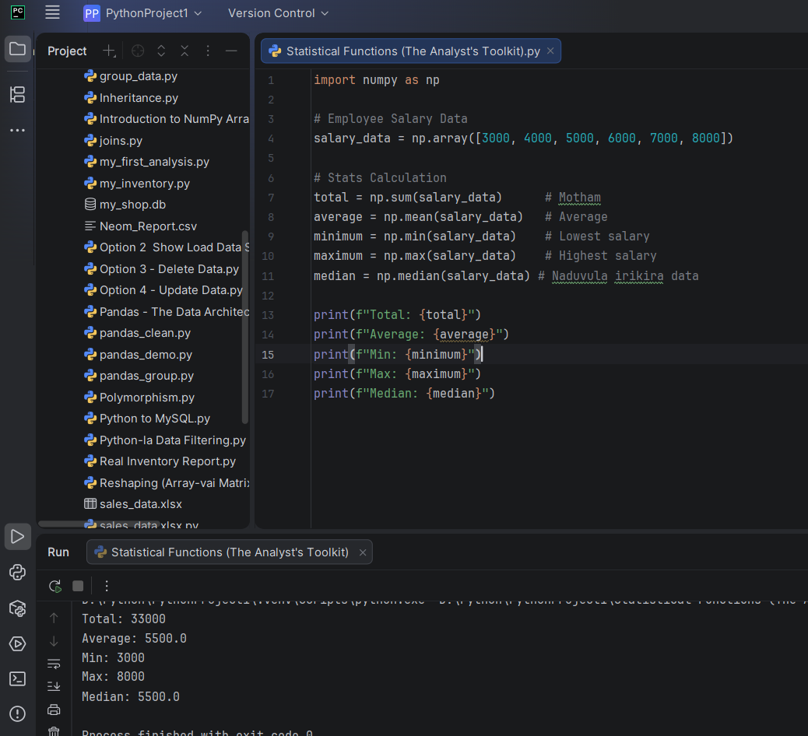
Teacher median enda naduvula irikira data endu sonniga aana result 5500 vandikidu eppadi
Arumaiyana kelvi, Irshad! Median eppadi 5500 vandhuchu nu ippo clear-a paarkkalam. Idhula oru chinna Math magic irukku.
🔍 Median (Naduvu Value) Calculation:
Namma kitta irukkura data: [3000, 4000, 5000, 6000, 7000, 8000]
- Count (Evvalavu data irukku?): 6 numbers. (Ithu Even number - Irattai en).
- Odd number-a iruntha: Naduvula ore oru number dhaan irukkum (Adhu dhaan median).
- Even number-a iruntha: Naduvula rendu numbers irukkum.
Inga paarunga:
- 3000, 4000, 5000, 6000, 7000, 8000
- Naduvula 5000 and 6000 irukku.
Median Formula for Even: NumPy computer enna pannum na, antha rendu number-aiyum kooti, 2-aala vaguthidum (Average of middle numbers).
💡 Teacher's Summary:
- Data-va sort panni, naduvula irukkura number-ai edukkurathu dhaan median.
- Even-a iruntha, naduvula irukkura rendaiyum kooti average edupom.
- Odd-a iruntha (Ex: [10, 20, 30]), naduvula irukkura 20 dhaan direct-a median-a varum.
Ippo 5500 eppadi vandhuchu nu purinjidha Irshad? Namma Data Analysis-oda core logic-ai neenga romba deep-a purinjikiteenga.
Ippo namma "Mini-Analysis App" (Project)-kku ready-a? Ellathaiyum serthu, database-la irunthu data-vai eduthu, NumPy/Pandas vachi analyze panra oru project-ai start pannuvoma? Adhu unga Portfolio-vukku romba periya strength-a irukkum!

